PARTES INTERESADAS POR CADA PROCESO

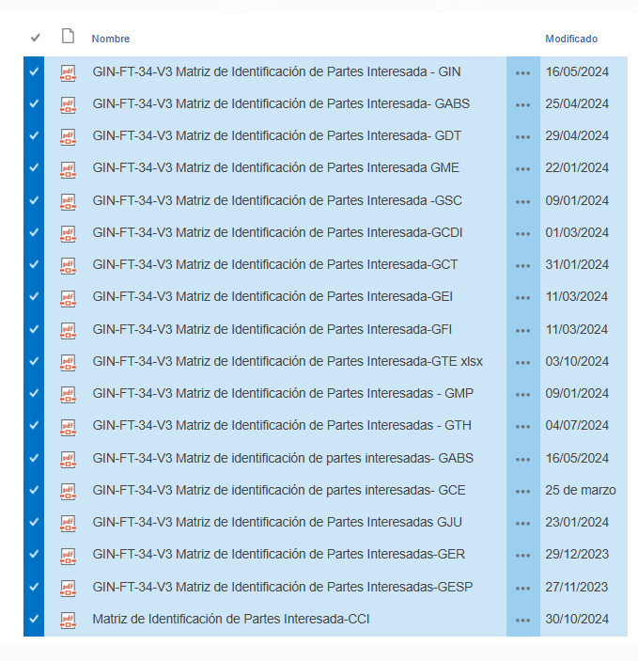<http://intranet.unp.gov.co/SGI/Documents/Forms/AllItems.aspx?RootFolder=%2FSGI%2FDocuments%2FSISTEMA%20DE%20GESTION%2F03%2EMANUALES%2FManual%20Gesti%C3%B3n%20Estrat%C3%A9gica%20Integrada%2FANEXOS%2FANEXO%206%20MATRIZ%20DE%20INDENTIFICACI%C3%93N%20DE%20PARTES%20INTERESADAS%20POR%20PROCESO&FolderCTID=0x01200029C080505609C84488350FFA984DF75A&View=%7B569EDF3E%2DB475%2D4532%2D9E44%2D3FEB5E3765EB%7D>