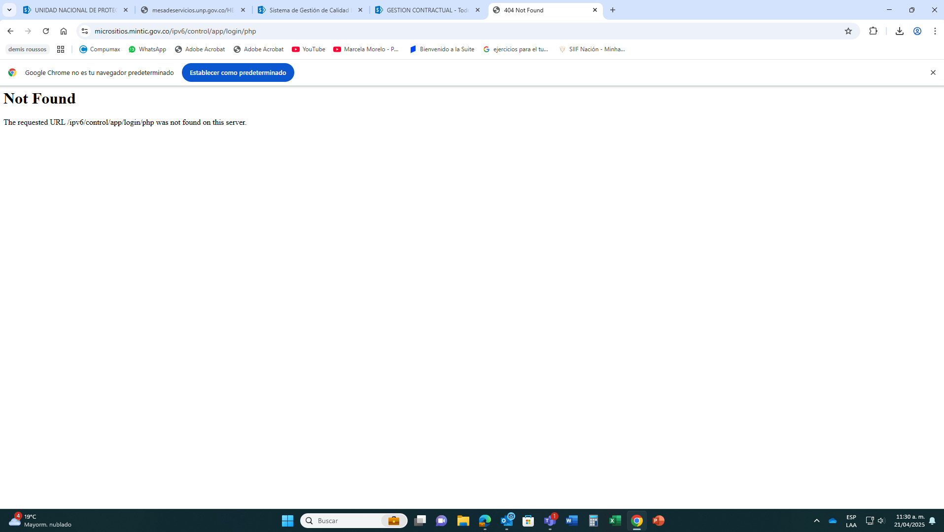
https://micrositios.mintic.gov.co/ipv6/control/app/login/php

